About Lejre
Lejre is situated in the middle of Zealand in an ancient Viking landscape. We are surrounded by beautiful nature which we are very proud of. You can find both ancient burial mounds, fjord and forests.
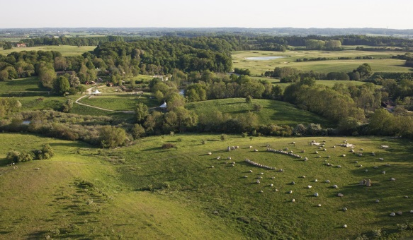
Lejre has one of the most popular tourist attractions called “The Land of Legends”. In Danish we call it “Sagnlandet”. It’s a very interesting place to visit for everyone who likes nature and history. You can experience how it was to live in the Viking age. You can cook your own meal, made of herbs from the area, over the firewood. You can also craft your own tools, and other stuff.
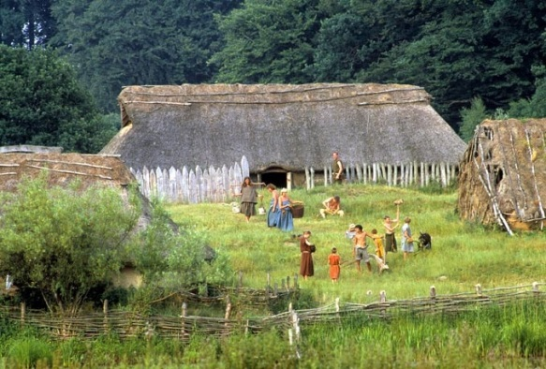
We have seven schools in Lejre county. They are located in different parts of the area. The
schools each have between 200-500 students.
We also have a youth-school, where you can chose between different classes, and meet new young people from the other schools.
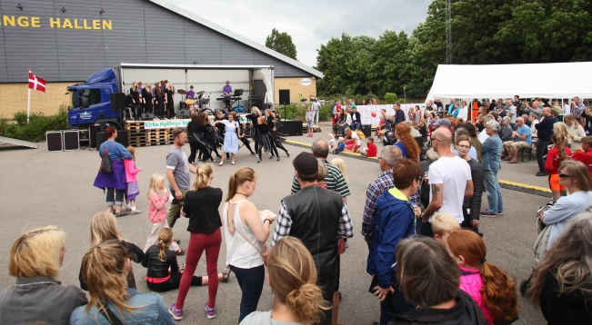
The four biggest towns in Lejre are: Hvalsø, Kirke Hyllinge, Osted and Lejre.
Lejre was a kind of capital for the Vikings in ancient ages.
Lejre is also known for organic farming. Every year, one of the farms is visited by several thousands of people, when the organic milk cows are let outside after the winter. Even the Danish crown princess and her children have visited the farm.

